Usability Report on Web Applications

Report Writing

**Abstract**

I extremely felt an immense pleasure for setting down the synopsis of the report entitled “Usability in Web Application”.

**Table of Contents**

1. Introduction: 6

1.1. Usability 6

1.2 Importance of Usability 6

2. Literature Review: 7

2.1 7

3. Examples of Web Application 9

3.1 Focusmate 9

3.2 Amazon 10

4. Analysis: 11

4.1 Golden Rules for Focusmate and Amazon: 11

4.1.2. Enable frequent users to use shortcuts: 13

4.1.3 Design dialog to yield closure: 15

4.1.4 Offer simple error handling: 17

4.1.5 Permit easy reversal of actions: 19

4.1.6 Support internal locus of control 21

4.1.7 Reduce short - term memory load 23

4.1.8 Offer informative feedback 25

4.2 Jacob Neilson’s 10 Heuristics 27

5. Conclusion 31

6. References 31

7. Appendix 31

# Introduction:

## 1.1. Usability

Usability refers to the capability of a system to be usable. Generally, it means the way a system can interact with the users to provide user’s immediate needs and context with ease and satisfaction. This definition generates from the idea of the human behaviour and psychology. Humans by nature crave comfort and want to achieve any amount of success in any work with the bare minimalistic effort and the same applies while designing an interface. One of the key factors of usability is to optimize the user experience that is designing website in such a way that it encourages effective and efficient human-computer interactions Simply, if a system is easy to use and completes any task of the user with low effort and no errors then a system is said to be usable.

## 1.2 Importance of Usability

While designing a web interface, the designers need to consider the main objective of usability i.e. focusing on reducing the user’s workload by making the use of the system’s abilities. The design should strive for simplicity, should be aesthetically pleasing, accessible and it should maintain clarity while ensuring the goals of the website. If the website application is hard to navigate and users lose their track due to a cluttered design, it might be frustrating for the users which can affect the overall success of the web application.

# Literature Review:

## 2.1

A successful web interface design on user interface (UI) and user experience (UX) depends on usability. To design an interface that is both easy to navigate and user-friendly, it should include navigation bars with predictable patterns, allowing users to effortlessly move through features without confusion. The interface design should be minimalistic to reduce clutter and should be visually appealing, making it intuitive. Consistency in design elements and their placement develops user familiarity and comfortability. These principles not only help minimize human effort for successful completion of tasks but also creates an environment for users to feel comfortable and engaged. Additionally, prioritizing accessibility and inclusivity by maintaining the standard like the Web Content Accessibility Guidelines(WCAG) ensures that all the user’s requirements are met and satisfied.

For designing any kind of interface, there are laws that need to be implemented for enhancing usability and those laws include Schneiderman’s eight golden rules and Jacob Neilson’s 10 usability heuristics. Those rules are key to boosting usability in interface design and some of those include ensuring consistency across the interface, using short cut keys for regular users and so on. According to the past studies, users found it easy to use the web applications which had similar consistent patterns to the ones they were using frequently. Setting a goal for the web design and communicating those goals to the target audience also helped the web application to perform better in terms of user’s expectations. Providing information about the web application through FAQ’s is also crucial to help navigate the web application for new users. Also, because of the limitations of human’s working memory, a web application will be most useful if it’s designed in such a way that the user doesn’t have to remember any details from the web app and when the information from one page doesn’t have to be remembered and applied in another page of the same app. If there happens to be any errors in the system, then it should be clearly communicated to the users via informative dialog box with solutions that help users to correct mistakes without hassle. Providing instant feedback about the state of success or failure of a task or displaying the time for the app to load can help a lot to avoid user’s frustration and confusion while using a system. Introducing shortcuts can significantly speed up task execution for frequent users. It's also important to provide instant feedback for actions to avoid user confusion and frustration. Usage of breadcrumbs, mega menu etc. to track the user’s usage history can help a lot for navigation across the system.

# Examples of Web Application

## 3.1 Focusmate

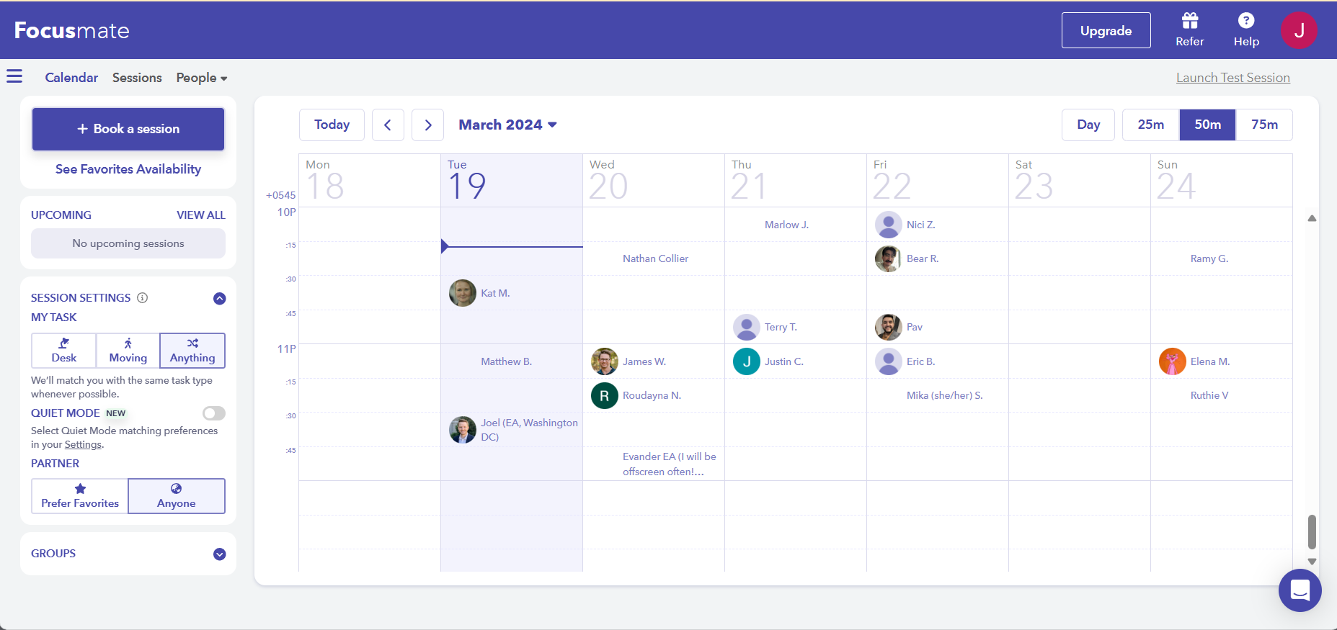

Figure 1: Focusmate app

Focusmate is a web-based application that focuses on “getting things done”. This productivity-based application helps users to schedule meetings for virtual coworking. The main goal of focusmate is to connect like-minded people to work together so that they can hold each other accountable while keeping each other motivated for dedicated sessions.

## 3.2 Amazon

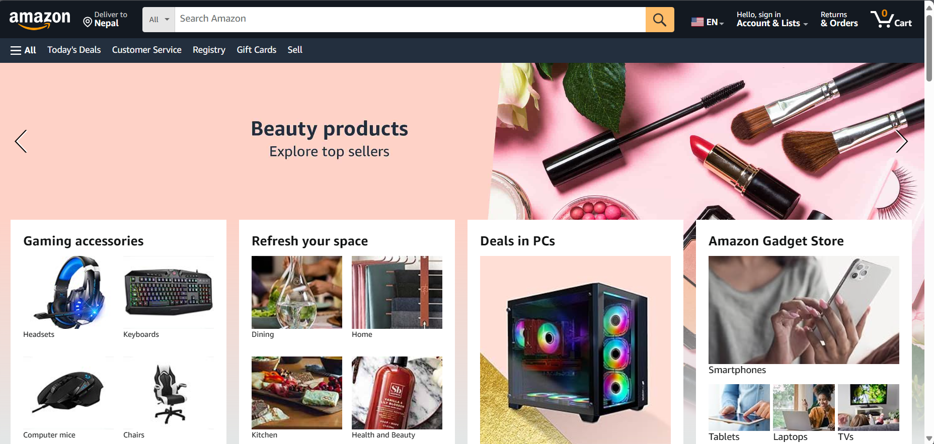

Figure 2: Amazon dashboard

Amazon is an ecommerce web application that helps users to purchase products and services from around the globe.

# Analysis:

## Golden Rules for Focusmate and Amazon:

4.1.1 Strive for consistency:



Figure 3: Consistent dashboard design in Focusmate

Focusmate web application has a consistent design and uses simple layout to help users to navigate the system.

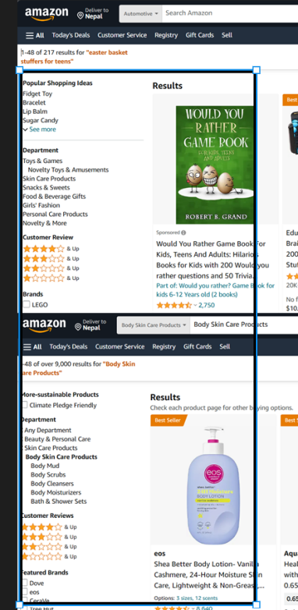

Figure 4: Consistent design in Amazon

The layout in Amazon is consistent, informative and allows effective navigation. It has dropdown menu to search for products in categories.

### 4.1.2. Enable frequent users to use shortcuts:

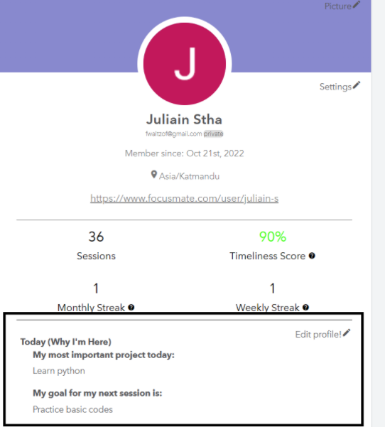

Figure : Shortcut usage in Focusmate

The system provides wide range of features including shortcuts. While booking a session, users don’t have to specify the goals of their session every time, they can keep a fixed goal for every session they take.

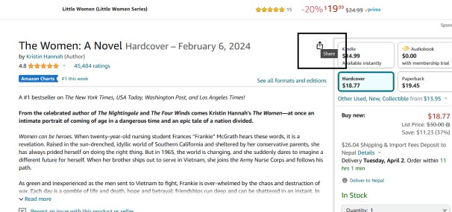

Figure 6: Shortcut usage in Amazon

In Amazon, we can use the share button to refer the product to other users so that they don’t have to remember the information of the product while giving the referral.

### 4.1.3 Design dialog to yield closure:

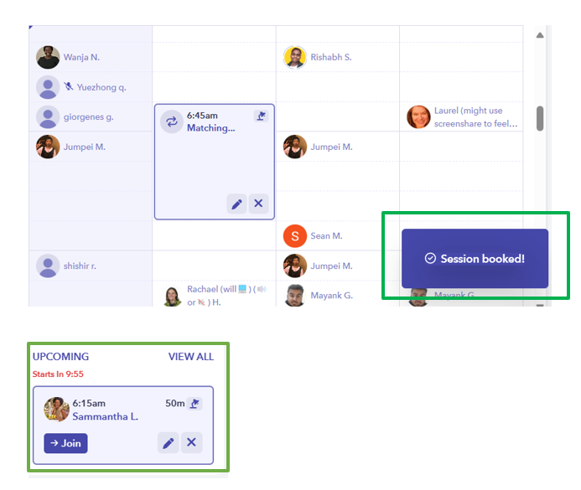

Figure 7: Informative dialog box to yield closure

In Focusmate, the users are allowed to book a session and all the information regarding succession or failure about the session is informed to the users through dialog boxes.

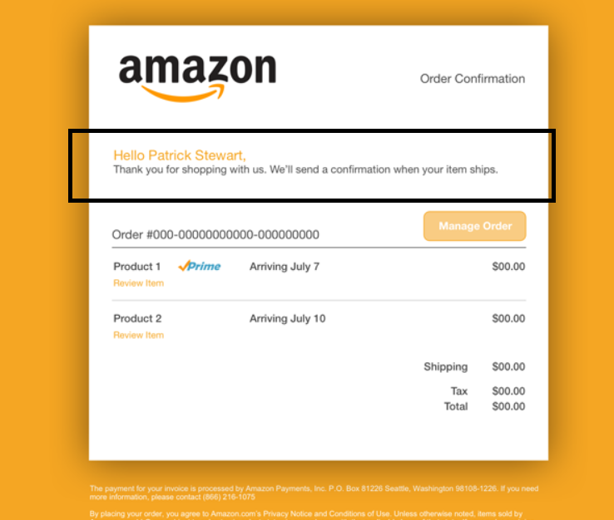

Figure 8: Informative feedback to yield closure in Amazon

After the order is confirmed, the users are informed about their order details by redirecting them to a next page.

### 4.1.4 Offer simple error handling:

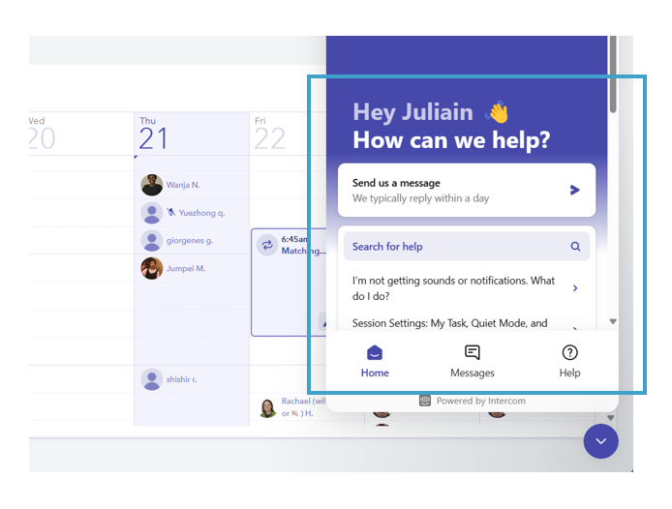

Figure 9: Error handling in Focusmate

If a user encounters any error in the system, they can simply go to the dropdown button in the dashboard to solve the problem and get solutions.

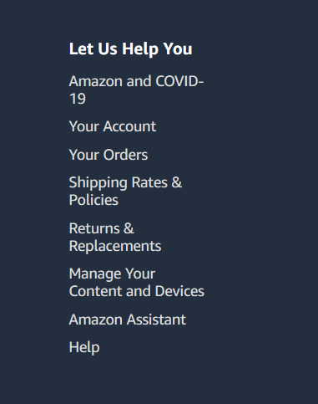

Figure 10: Error handling in Amazon

In Amazon, if a user gets confused in any of the processes while using the system, they offer simple error handling which can be accessed from the app itself.

### 4.1.5 Permit easy reversal of actions:

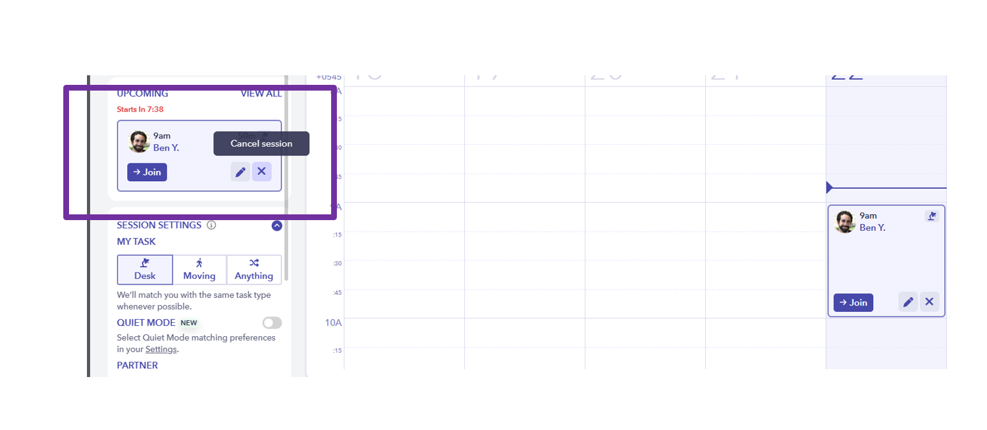

Figure 11: Feature showing reversible action in Focusmate

If a user accidentally cancels the session, they can track back to their session through the session’s history providing easy reversible of actions.

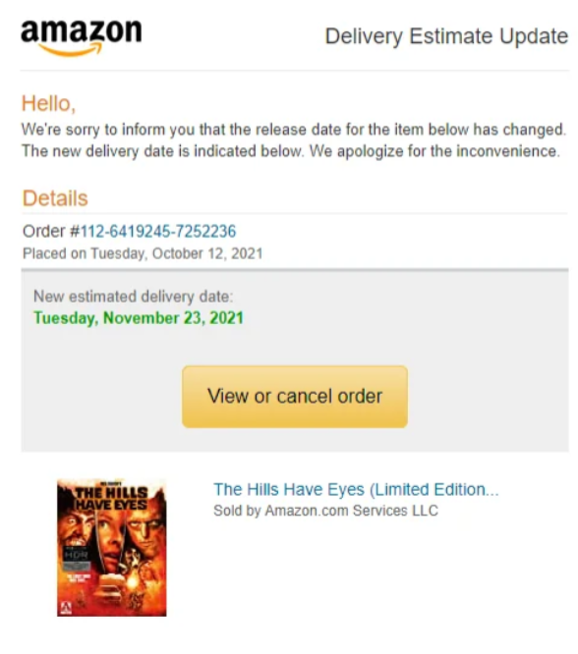

Figure 12: Feature showing reversible action in Amazon

After the order is placed, if the user wants to cancel the order, Amazon offers cancellation of the product as well through interactive elements.

### 4.1.6 Support internal locus of control

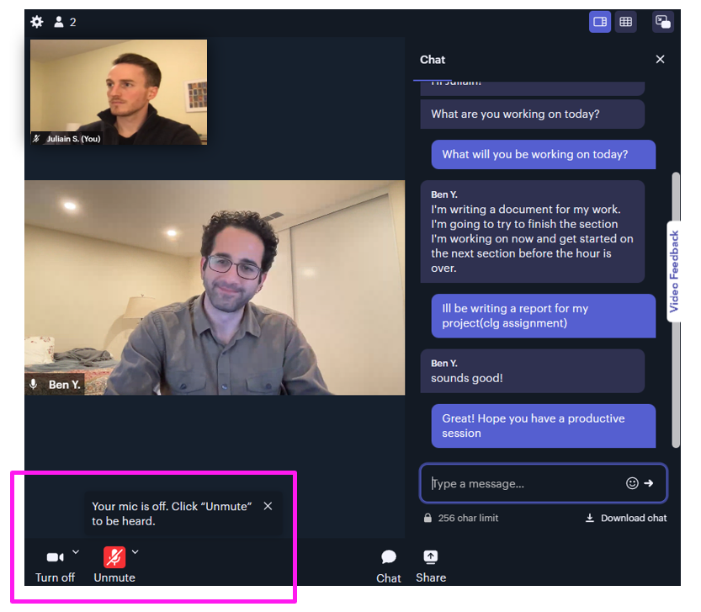

Figure 13: Internal locus of control given to users in Focusmate

Focusmate permits users to enable and disable certain features to let the users have control over the system.

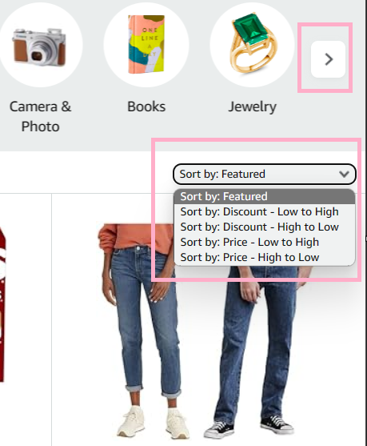

Figure 14: : Internal locus of control given to users in Amazon

In Amazon, users can search for their desired products by their preference which can make the users feel like its them that’s controlling the system according to their need than feeling like the system is controlling their actions.

### 4.1.7 Reduce short - term memory load

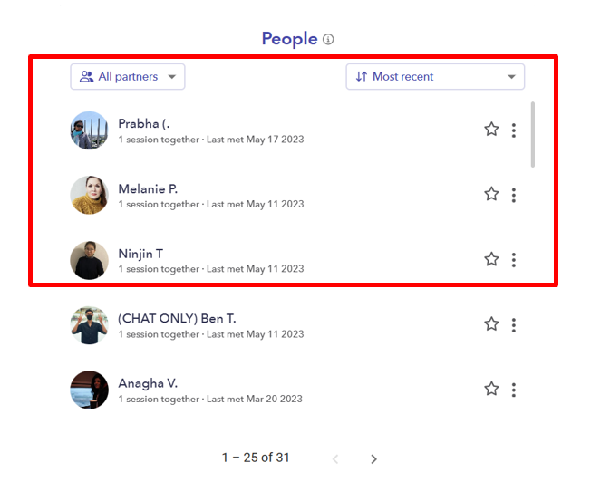

Figure 15: Feature enabling users to reduce memory load in Focusmate

After the completion of the session, the users can see their partner history so they can their favorite body doubling partner to the list and use the same list to book session with their favorites.

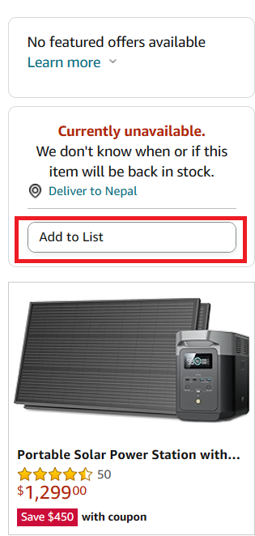

Figure 16: Feature enabling users to reduce memory load in Amazon

After the user is done with browsing, they have the option to add their desired product to a list so that they can view their list later on and place their desired order. This feature helps user to reduce the memory load as they don’t have to remember each of the products while placing an order.

### 4.1.8 Offer informative feedback

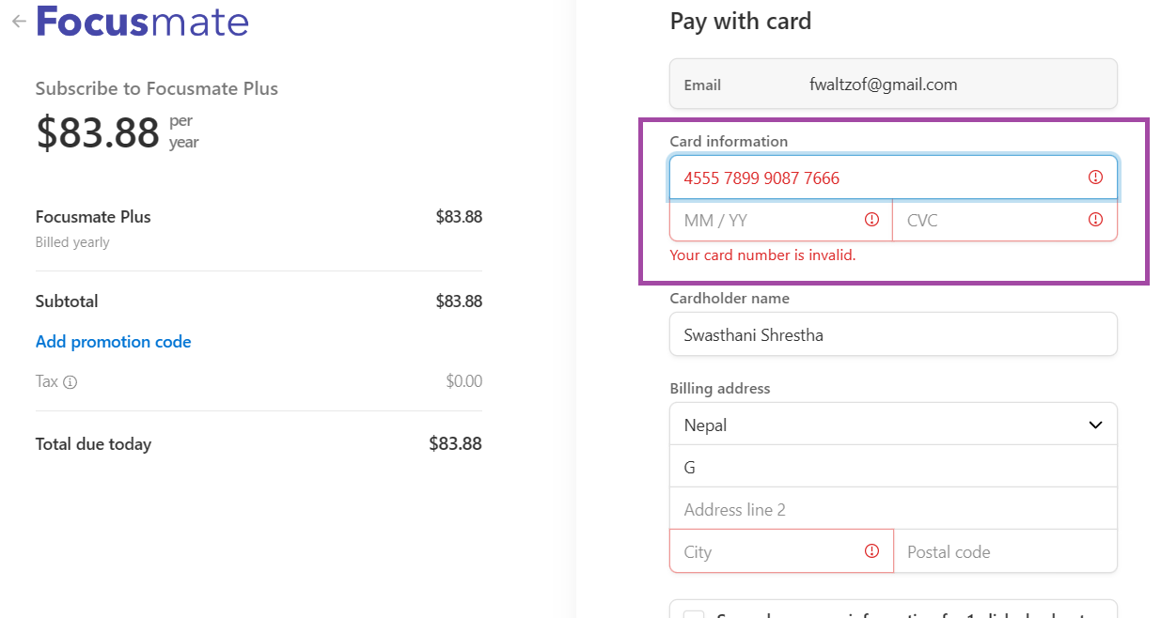

Figure 17: Informative feedback by the system in Focusmate

The above shows that the feedback offered by the system due to form validation error. This helps remind the user that the information they have given is invalid.

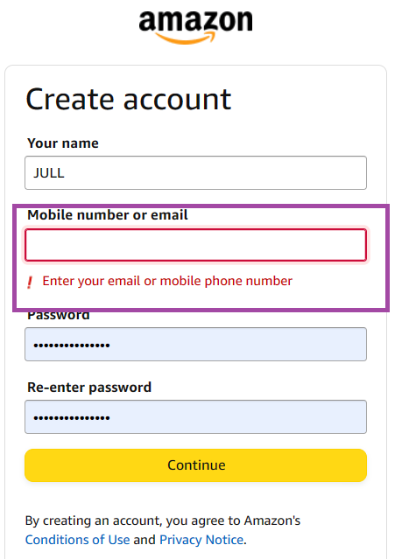

Figure 18: Informative feedback by the system in Amazon

When the user enters wrong credentials, the system provides the feedback so as to inform the user about the validation of the process.

## Jacob Neilson’s 10 Heuristics

### Visibility of system status

This rule can be explained by Schneiderman’s two rules which are mentioned in: 1.3. and 1.8.

* 1. Match between system and the real world

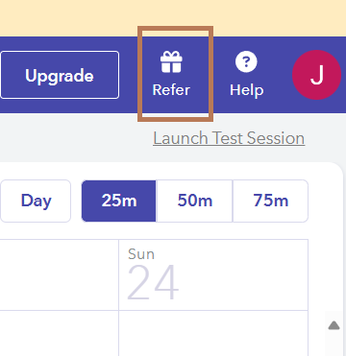

Figure : : Icon usage in Focusmate showing the match between system and real world

The ‘gift’ icon used in the system to denote a referral gift resembles the gift received in real life. This is done to increase the comfortability of user to the system.



Figure : Icon usage in Amazon showing the match between system and real world

The ‘cart’ icon used in this system closely resembles that of the cart that is used while shopping in real world. Because Amazon is an e commerce website, the resemblance of shopping cart is an excellent way to maintain familiarity of users with the system.

* 1. User control and freedom

This rule can be explained by Schneiderman’s two rules which are mentioned in: 1.5. and 1.6.

* 1. Consistency and standards

This rule can be explained by Schneiderman’s one of the rules mentioned in: 1.1.

* 1. Error prevention

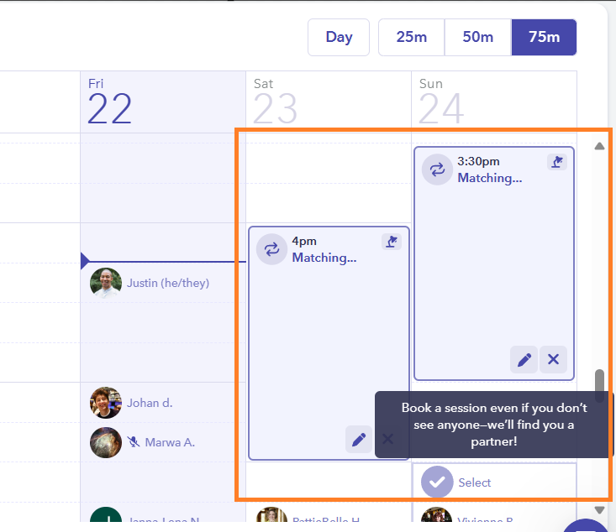

Figure : Error prevention in Focus mate

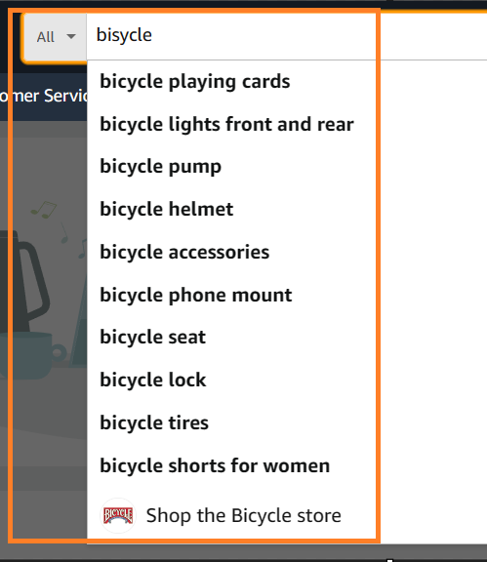

Figure : Error prevention in Amazon

* 1. Recognition rather than recall

This rule can be explained by Schneiderman’s two rules which are mentioned in: 1.7.

* 1. Flexibility and efficiency of use

This rule can be explained by Schneiderman’s two rules which are mentioned in: 1.2. and 1.5.

* 1. Aesthetic and minimalist design

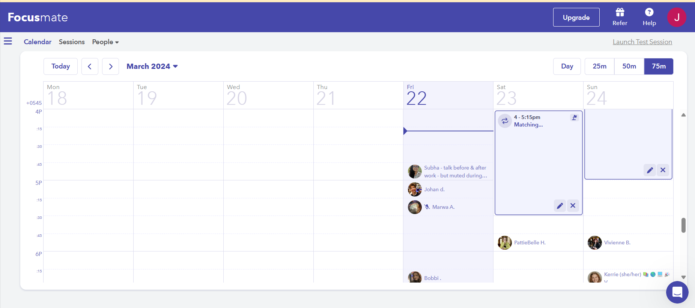

Figure : Aesthetic and minimalistic design of Focusmate

The well structured layout and minimalist design of Focusmate looks visually appealing and less intimidating to the users increasing customer satisfaction.

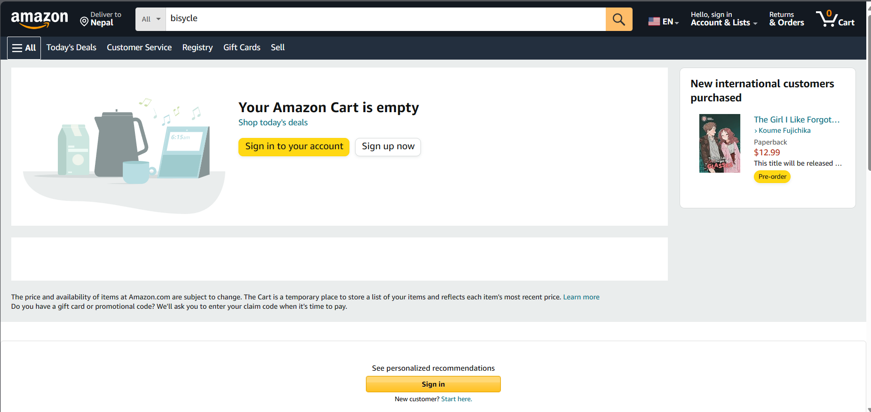

Figure : Aesthetic and minimalistic design of Amazon

The minimalistic and aesthetically pleasing design of Amazon doesn’t overwhelm users while using the system.

* 1. Help users recognize, diagnose, and recover from errors

This rule can be explained by Schneiderman’s one of the rules which is mentioned in: 1.4.

* 1. Help and documentation

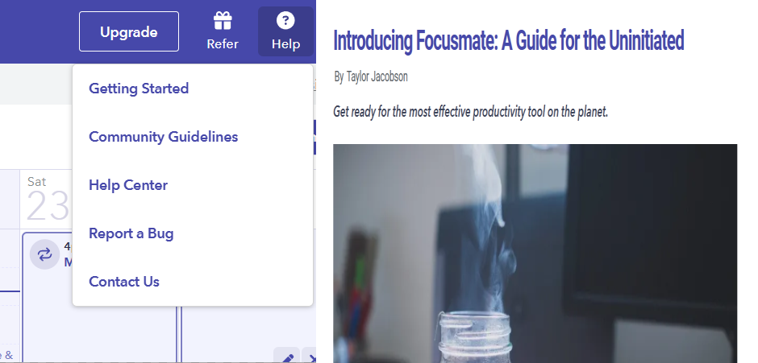

Figure : Help and Documentation of Focusmate

Help and documentation is very useful to the new users of the system and Focusmate has it all figured out with features that can directly help the users to even contact the system owners for help.

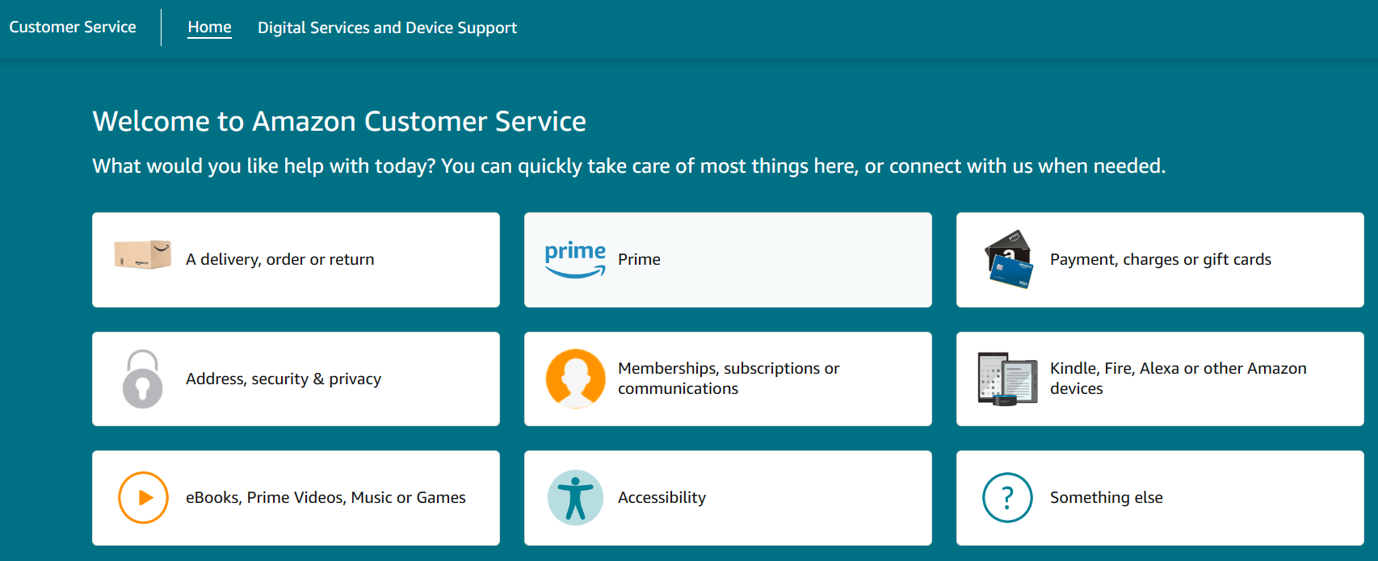

Figure : Help and Documentation of Focusmate

Customer service is provided by Amazon to increase user’s satisfaction and every thing is well documented about the web application that helps the new users to tackle the problems or confusion for the new users.

# Conclusion

Through this report there is the explanation and introduction of the various rules of the usability by Schneiderman and Nielsen. These rules are solely responsible for creating the perfect usable system. As these rules outcomes in making the user-friendly and uplifting the user satisfaction.

Also, there is the analysis of the two provided product named Focusmate and Amazon web application. Their usability is analyzed in the basis of the rules of the Schneiderman and Nielsen. Both of the software follows the guidelines and resulted as perfect usable system.

The literature review of the usability in the web applications offers a framework for comprehending how to design a user desired interface that prioritized the user demands and preferences.

Overall, the rules and guidelines are the core factors that should be followed by developers for creating user friendly UI/UX design.

# References

# Appendix

# 